LSFD Capstone project

Software Development 2016-2017

Program Tutorial

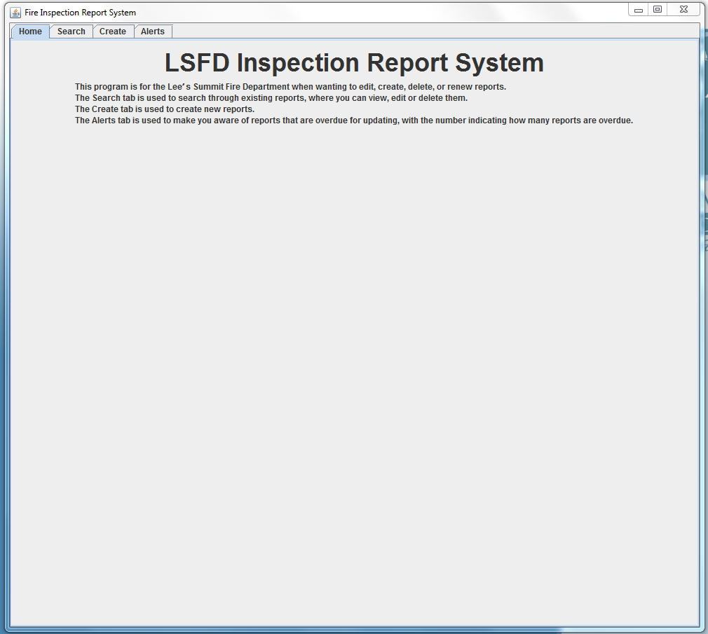

Home screen

1. The screen gives a brief description of each tab within the program
2. Click a tab at the top of the screen in order to get to the desired screen
   1. The search tab takes you to the page where you can search for a record
   2. The create tab sends you to the page where you can create a new record
   3. The Alerts tab sends you to the page where you can view overdue records that are over a year old

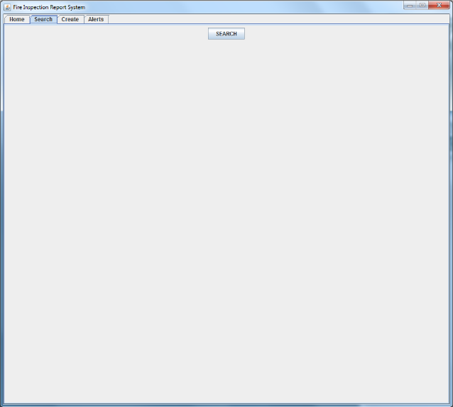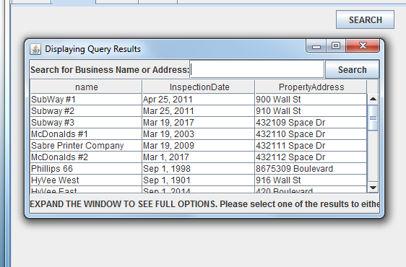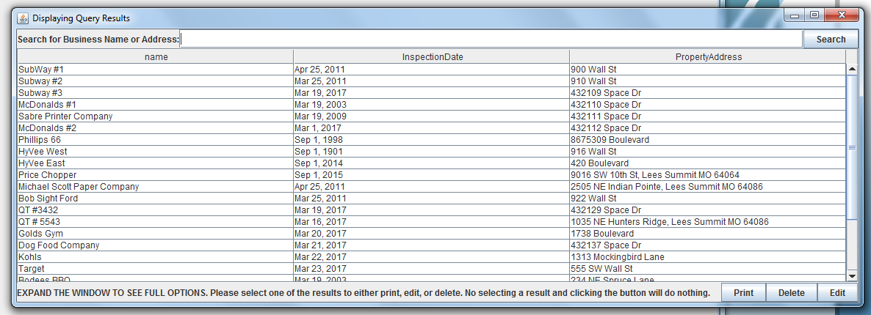

Search Screen

1. Click the button that says “SEARCH” to bring up the search window
2. In the new window, you can type in a business name or address and click the “Search” button, and you will be given results with the thing you put into the search
3. After expanding the little window, you can see 3 new buttons: “print”, “edit”, and “delete”.
4. The edit function allows you to edit the currently highlighted record that was searched for (or at least that’s what it would be used for if we were able to finish it)
5. The delete function allows the user to delete the currently highlighted record, and displays a warning before doing so the user doesn’t accidentally delete any records

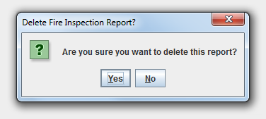

1. The print button allows you to print the record to the screen and to a file on your computer, to be printed from a printer if needed

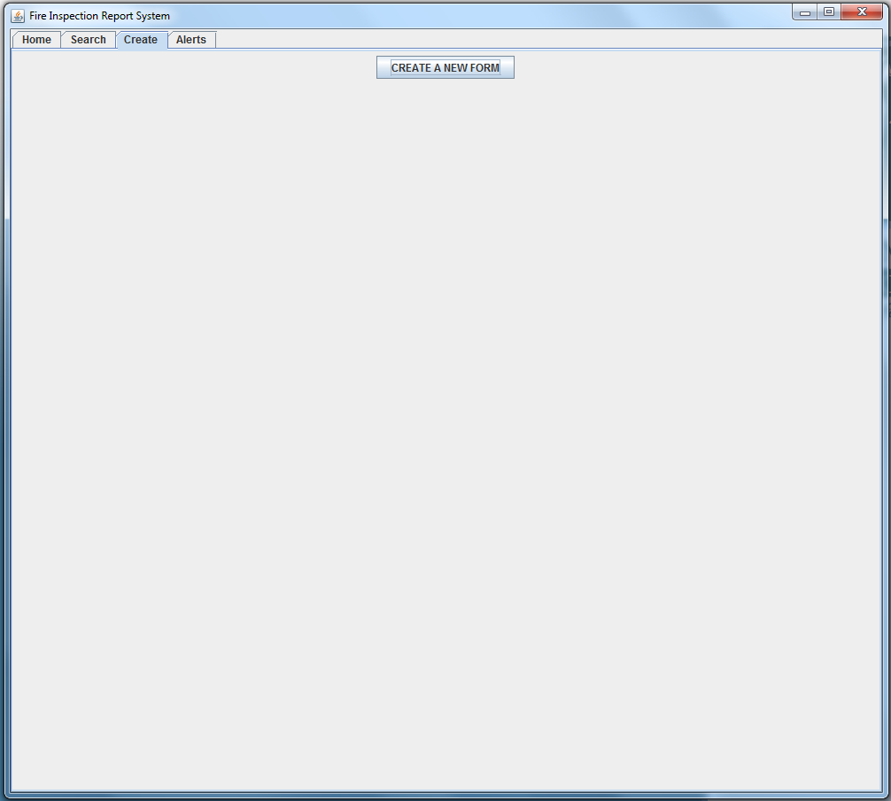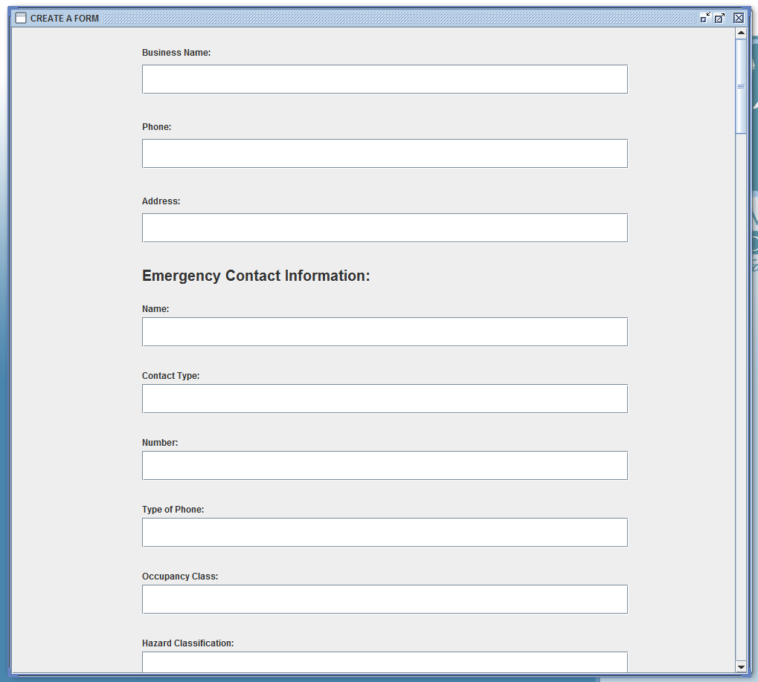

Create Screens

1. Click the button on the initial screen which will bring the user to the form where they can fill out a new report
2. On the new screen, you can fill out a form to enter in, going field by field.
3. The user can scroll down to continue the form without going to a new page
4. Once all the fields are filled in, the user can select the “Submit” button to submit their report to the database

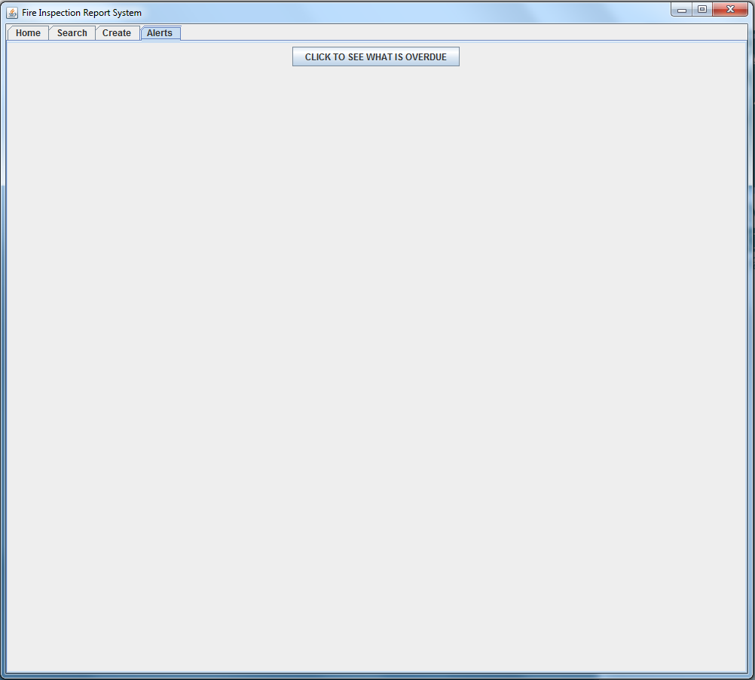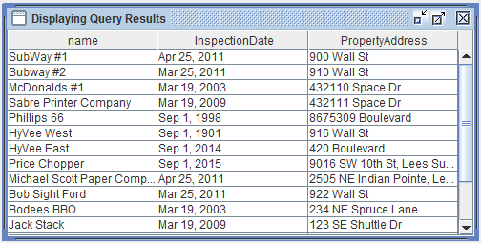

Alerts screens

1. Clicking the button that says “CLICK TO SEE WHAT IS OVERDUE” will open up a separate window that shows which reports are overdue in the database
2. The results shown are only shown if they are over a year old and need re-inspection